10/10/2019

Eco Streets

Pre-feasibility Study

Table of Contents

Purpose of the document 2

Brief description of the project 2

Executive summary 2

SWOT analysis (Strengths, Weaknesses, Opportunities, Threats) 3

Strengths 3

Weaknesses 3

Opportunities 3

Threats 3

Methodology 3

Legal study 3

Marketing feasibility study: 3

Technical feasibility study: 4

Financial feasibility study: 4

Economical and commercial feasibility: 4

Social and national feasibility study (SNF) 4

Organizational feasibility Study 4

Study team 5

Market entry timing 5

# Purpose of the document

A group of undergraduate engineers, from various departments, decides to find their own firm that serves and invests well in the city. It is aimed towards importing electric cars from the world to the market and will start building charging stations for electric vehicles. The team is going to work unrelentingly for this organization during the following weeks.

The mission of the organization is to serve the community and to engage in the sustainability objectives as we are environmentally conscious. The following technical report outlines the pre-feasibility analysis and the purpose of starting up the company.

# Brief description of the project

Electric cars are becoming more mainstream, and people are starting to wonder whether an electric car is right for us. As the technology supporting electric cars and batteries continue to improve, drawbacks such as high cost, limited range, performance issues, long charge time, and lack of charging stations are fading away but number of electric charging stations increasing with a good rate.

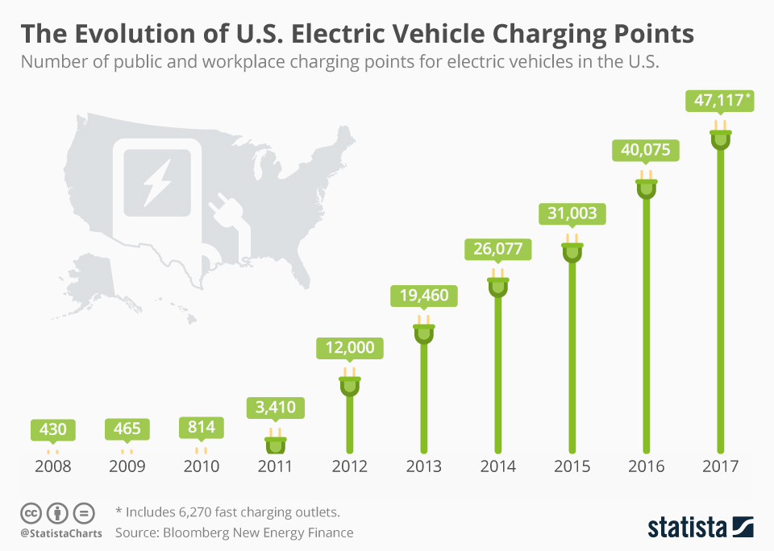

Electric cars have a lower running cost compared to conventional gas vehicles each year. As the cost of electric cars becomes the same as or less than existing vehicles the choice to ‘go electric’ will be obvious. Charging stations we have will serve our purpose to ‘go electric’ but it isn’t enough as we still we get the electricity from the fossil fuel so we want to have charging stations with solar panels so we can ‘*go eco*’ and have ‘*Eco-Streets’*.

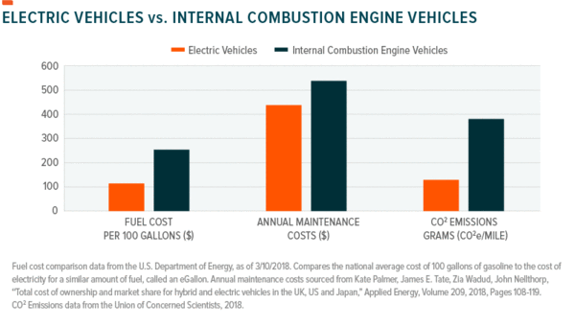

You are in the future as if you start driving an electric car then you’re obviously planning for the future. In addition to being counted among the ranks of the “coolest people around”, you’ll be making a difference for the environment, and saving money.

We will have less maintenance with fewer moving parts, there are not many things to break or that need fixing on an electric car. This will save you a lot of time and money over the years. Your mechanic might get a little lonely, but we will have our maintenance to serve you if any problems occur or any upgrade you will need. The biggest issue may be having to change out your battery, but most models today come with an 8-year/100K mile warranty. Batteries can last up to 15 years in a mild climate, that’s pretty good value.

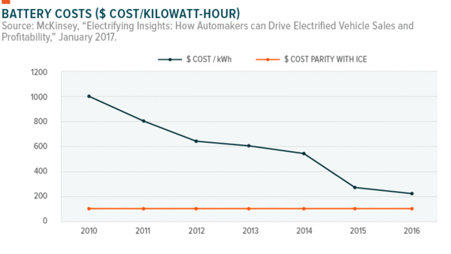

# Executive summary

In brief, we want to change the concept of the automotive industry to ‘Go Electric’ by importing electric cars with all its gadget and start our maintenance centers to serve them. Having our electric charge station to serve those cars and use solar panels on those station to ‘Go Eco’ as our main purpose is to have *‘Eco Streets’* and electric vehicles will be our start.

# SWOT analysis (Strengths, Weaknesses, Opportunities, Threats)

## Strengths

* We are leading a new technology in Egypt and provide integrated service for it.
* We start to think of our environment so that we have an earth to live on in the future.
* Having support from Egyptian government as it supports the solar panels projects.

## Weaknesses

* Our vehicles have smaller range than the cars that use internal combustion engines.
* Some restrictions from the Egyptian government on importing some kind of electric machines as brush-less dc motors and its controllers.

## Opportunities

* Having a new market we will give us a good opportunity in growing our business faster.

## Threats

* This company will be a threat for the big and old companies as if they won’t develop them self and start in importing electrical vehicles they will lose their market so our success means their failure and they won’t let that happen easily.
* Dealing with a market that has a lack of knowledge about the electrical vehicles system
* Threats about the electric vehicles range to be used in marketing against us.

# Methodology

After the pre-feasibility study is agreed on, we will start immediately in the following

Legal study

Where we study legal position concerning investment and employment, insurance, taxes etc.

As we will have:

* Investment laws analytical study.
* Choosing the legal frame work of the project nature.
* Is it legally right to purchase the technology?
* The nature of taxes.
* The total cost of legal investment registration.

## Marketing feasibility study:

* Study of the factors and determinants of demand and supply.
* Examine the main structure and characteristics of the market.
* Market share estimate for your project.
* The market prices for the products (goods or services).
* The estimation of total revenue for the project.

## Technical feasibility study:

* Are there enough raw materials and of the correct quality when needed for full year-round production?
* Is the cost of the raw materials acceptable?
* Can it be made by local workshops and are maintenance and repair costs affordable?
* What is the best design for the project layout?

## Financial feasibility study:

* Projects how much start-up capital is needed to cover all costs estimated previously in the technical study, sources of capital, returns on investment (ROI), etc.
* Determines the appropriate financial structure on the bases of the available financial sources.
* The financial structure cost estimate.

## Economical and commercial feasibility:

Estimates expected costs and revenues during the life span of the project.

The economic study will focus on several indicators such as:

* Depreciation.
* Return on capital.
* Payback period.
* Net present value (NPV).
* Cost /Benefit Analyses Profit index or.
* Internal Rate of Return (IRR).
* Rate of Return/cost.
* Net Return/ Cost.

## Social and national feasibility study (SNF)

* Measures the project contribution to the society and in the national economy.
* Criteria for social profitability
* Project contribution in job creation.
* The enterprise's contribution balance of payments.
* The enterprise's contribution to value added (GDP).
* Project contribution in strengthening national currency.
* The negative effects of the project on the society.

## Organizational feasibility Study

Defines the corporate structure of the business.

As the founder are engineers in various specializations, we will be capable of starting the company and start hiring some employees.

# Study team

Pre-study Headed by: Ibrahim Mostafa  
ID: 4715

Legal study Headed by: Omar khattab

ID: 5247

Marketing study Headed by: Omar Ashraf

ID: 4738

Technical Study by: Mohannad Mahmoud

ID: 5123  
Financial and Economic Study Headed by: Wadie Bishoy

ID: 5074

Social and National Study Headed by: Anas Hamed Mohamed

ID: 4989

Organizational Study Headed by: Islam Mustafa

ID: 4738

## Market entry timing

As we work on our planned time line. We will be able to enter the market by 2023

References

<https://www.fleetcarma.com/why-electric-cars-are-better-than-gas-top/>

<https://vancouversun.com/news/local-news/e>

[https://enrg.io/total-electric-cars-decrease-demand-gasoline-2030/](https://enrg.io/total-electric-cars-decrease-demand-gasoline-2030/?fbclid=IwAR0MkBCGYLZkI5H2uN9HPZD1xuFr4BhEM5uXVjI9TOSzg7MKwaA83lITC-Q)

<https://evannex.com/blogs/news/four-charts-showcase-why-electric-cars-will-take-over>